**CZECH UNIVERSITY OF LIFE SCIENCES PRAGUE**



**Faculty of Economics and Management**

**System Engineering and Informatics**

(Object and Relationship Database)

**Instructor: Prof. Ing. Vojtech MERUNKA Ph.D.**

Prepared by:

**Rabendra Pd. Shrestha**

**Table of content**

Problem Description ------------------------------ 1

Conceptual Model of OOD ----------------- 1

OOD Data ------------------------- 4

OOD Implementation ----------------------- 6

RDMS Class Diagram ------------------- 7

RDMS Data ------------------------ 8

RDMS Implementation ----------------------- 9

Conclusion --------------------- 11

**List of Figures**

Fig. 1: OOD Class Diagram ------------- 1

Fig. 2: OOD drug data ------------- 4

Fig. 3: OOD chemical data -------------------- 5

Fig. 4: OOD country data -------------- 5

Fig. 5: OOD treatment data ----------------------- 5

Fig. 6: OOD infection data ------------------ 5

Fig. 7: OOD query highInfected data ------------------------ 6

Fig. 8: OOD query type equals chemical data --------------------- 6

Fig. 9: OOD query drugTrafickling country -------------- 6

Fig. 10: OOD query medicalTreatment -------------- 6

Fig. 11: OOD query for formula of herb ---------------------------- 7

Fig. 12: RDMS class diagram ---------------- 7

Fig. 13: RDMS chemical table with data ----------------- 8

Fig. 14: RDMS country table with data ---------------------------- 8

Fig. 15: RDMS drug table with data -------------------- 8

Fig. 16: RDMS infection table with data ------------------------ 8

Fig. 17: RDMS treatment table with data -------------- 8

Fig. 18: RDMS query for drugTraffickling ------------------------- 9

Fig. 19: RDMS query for more infection country -------------------------- 9

Fig. 20: RDMS query for more infection drug ------------------ 9

Fig. 21: RDMS query for hightlyInfected infection ------------------------- 10

Fig. 22: RDMS query for mostHarmfulChemical drug ----------- 10

Fig. 23: RDMS query for drug with molecular ----------------- 10

Fig. 24: RDMS query for care, drug and infection ----------------------- 10

Fig. 25: RDMS query for various types of treatment under list --------------------- 11

Problem Description

This is the system of **“Drug Abuse”** that find on various things which effect the human beings in different age group, men and women, children, adult and old ages. Drug are combined of different componets like C17H21NO4 is Cocaine. Also from the drug it has infected to the persons as per the doses it takes and brings to the death or life end. There may solutions if treatment is in time so the life can save in time. Drug is also produced in the countries but as per the the demand and supply and produce more than one drugs the drug traffickling can figure out.

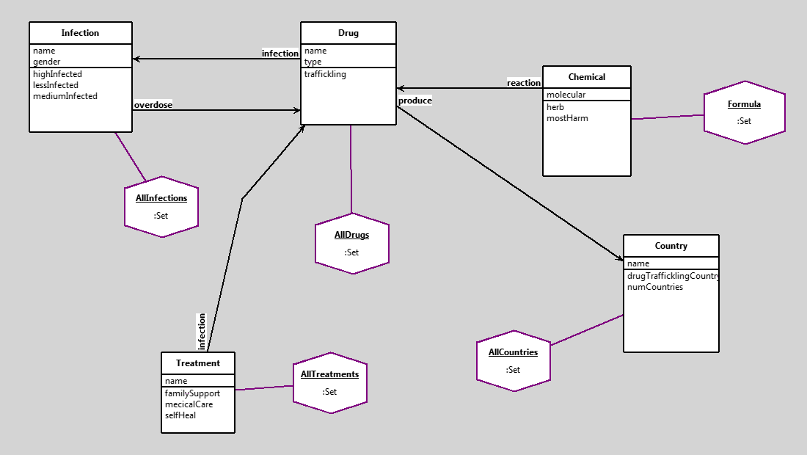Conceptual Model of OOD

Fig. 1: Object Oriented Database Class Diagram

Here the five class are created and they have relationship to each others. Each classes effect to other each classes and every classes has instances like the Drug class has AllDrugs object. The data stored in the class properties and method defined that what functions should be done as per the data stored or the other class object or the own class object which depends on the relationship. The following below has some of the code of the above diagram.

AllDrugs := Set new.

AllInfections := Set new.

AllTreatments := Set new.

Formula := Set new.

AllCountries := Set new.

d1 := Drug new.

d1 name: 'Hashish'.

d1 type: 'Plant'.

d2 := Drug new.

d2 name: 'Cocaine'.

d2 type: 'Chemical'.

d3 := Drug new.

d3 name: 'Heroin'.

d3 type: 'Chemical'.

d4 := Drug new.

d4 name: 'Kratom'.

d4 type: 'Natural'.

d5 := Drug new.

d5 name: 'Cannabis'.

d5 type: 'Natural'.

i1 := Infection new.

i1 name: 'Sweating'.

i1 gender: 'Both MaleFemale'.

i2 := Infection new.

i2 name: 'Loss of Consciousness'.

i2 gender: 'Both Male Female'.

i3 := Infection new.

i3 name: 'Comma'.

i3 gender: 'Both Male Female'.

i4 := Infection new.

i4 name: 'Nausea'.

i4 gender: 'Both Male Female'.

i5 := Infection new.

i5 name: 'Hallucinations'.

i5 gender: 'Both Male Female'.

i6 := Infection new.

i6 name: 'Cancer'.

i6 gender: 'Both Male Female'.

i7 := Infection new.

i7 name: 'Intense Feeling'.

i7 gender: 'Both Male Female'.

i8 := Infection new.

i8 name: 'Death'.

i8 gender: 'Both Male Female'.

i9 := Infection new.

i9 name: 'Muscle Spasms'.

i9 gender: 'Both Male Female'.

i10 := Infection new.

i10 name: 'Depression'.

i10 gender: 'Both Male Female'.

i11 := Infection new.

i11 name: 'Breathing Problem'.

i11 gender: 'Both Male Female'.

i12 := Infection new.

i12 name: 'Hepatitis'.

i12 gender: 'Both Male Female'.

i13 := Infection new.

i13 name: 'Dizziness'.

i13 gender: 'Both Male Female'.

t1 := Treatment new.

t1 name: 'Cognitive Behavioral Therapy'.

t2 := Treatment new.

t2 name: 'Motivational Enhancement Therapy'.

t3 := Treatment new.

t3 name: 'Family Based Treatment'.

t4 := Treatment new.

t4 name: 'Nafazodone'.

t5 := Treatment new.

t5 name: 'Fluoxetine'.

t6 := Treatment new.

t6 name: 'Rehabilitation'.

t7 := Treatment new.

t7 name: 'Detoxification'.

t8 := Treatment new.

t8 name: 'Narcotics Anonymous'.

t9 := Treatment new.

t9 name: 'Individual Counselling'.

t10 := Treatment new.

t10 name: 'Self-help'.

c1 := Chemical new.

c1 molecular: 'C21H30O2'.

c2 := Chemical new.

c2 molecular: 'C17H21NO4'.

c3 := Chemical new.

c3 molecular: 'C21H23N05'.

c4 := Chemical new.

c4 molecular: 'C23H30N205'.

c5 := Chemical new.

c5 molecular: 'C21H30O2'.

cu1 := Country new.

cu1 name: 'Afghanistan'.

cu2 := Country new.

cu2 name: 'Colombia'.

cu3 := Country new.

cu3 name: 'Thailand'.

t1 infection: d5; infection: d1.

t2 infection: d5.

t3 infection: d5; infection: d1; infection: d3.

t4 infection: d5.

t5 infection: d5.

t6 infection: d2.

t7 infection: d2; infection: d3.

t8 infection: d3.

t9 infection: d1.

t10 infection: d1.

c1 reaction: d1.

c2 reaction: d2.

c3 reaction: d3.

c4 reaction: d4.

c5 reaction: d5.

d3 infection: i3.

d4 infection: i12.

d5 infection: i10.

d1 infection: i10.

d2 infection: i4.

i3 overdose: d1.

i4 overdose: d4.

i12 overdose: d4.

i3 overdose: d3.

i1 overdose: d3.

i3 overdose: d3.

i6 overdose: d3.

i11 overdose: d3.

i7 overdose: d3.

i8 overdose: d2.

i2 overdose: d5.

d1 produce: cu1.

d2 produce: cu2.

d3 produce: cu1.

d4 produce: cu3.

d5 produce: cu1.

AllDrugs add: d1.

AllDrugs add: d2.

AllDrugs add: d3.

AllDrugs add: d4.

AllDrugs add: d5.

AllInfections add: i1.

AllInfections add: i2.

AllInfections add: i3.

AllInfections add: i4.

AllInfections add: i5.

AllInfections add: i6.

AllInfections add: i7.

AllInfections add: i8.

AllInfections add: i9.

AllInfections add: i10.

AllInfections add: i11.

AllInfections add: i12.

AllInfections add: i13.

AllTreatments add: t1.

AllTreatments add: t2.

AllTreatments add: t3.

AllTreatments add: t4.

AllTreatments add: t5.

AllTreatments add: t6.

AllTreatments add: t7.

AllTreatments add: t8.

AllTreatments add: t9.

AllTreatments add: t10.

Formula add: c1.

Formula add: c2.

Formula add: c3.

Formula add: c4.

Formula add: c5.

AllCountries add: cu1.

AllCountries add: cu2.

AllCountries add: cu3.

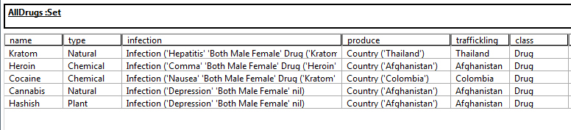 OOD DATA

All written information in script stored in the form of instances.

Fig. 2: Drug Data

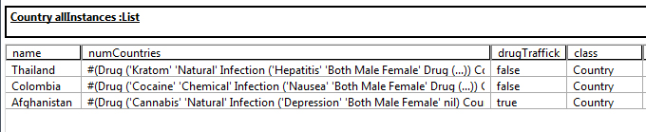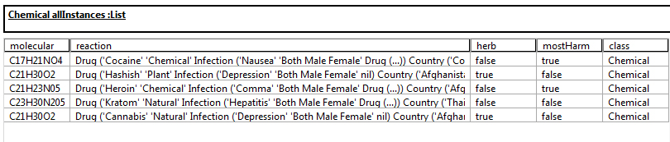

Fig. 3: Chemical Data

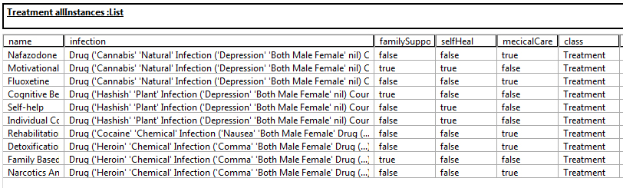

Fig. 4: Country Data

Fig. 5: Treatment Data

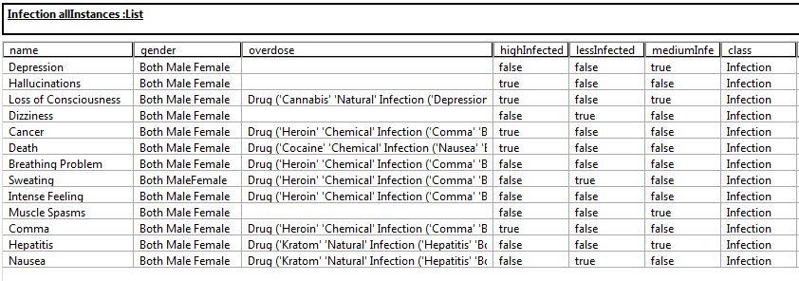

Fig. 6: Infection Data

OOD Implementation

Some of the queries and effects are as follow:

1. AllInfections select: [:x | x highInfected]

Method: ^#('Comma' 'Loss of Consciousness' 'Death' 'Cancer' 'Hallucinations' 'Death') includes: name

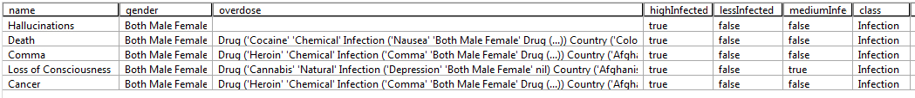

Fig. 7: Shows only High Infected Data which is true of highInfected method in the column

1. AllDrugs select: [:drug | drug type = 'Chemical']



Fig. 8: Shows the type where type equals Chemical property in the type column

1. D:\Working\CZU\2nd Sem\Relationship Database\Smalltalk\Software\Daskalos-runtime\Final Project\trafficklling country (method).jpgAllCountries select: [: x | x drugTrafficklingCountry]

Method: ^self numCountries size > 1

Fig. 9: Shows more than one country which produces drug and shows as the method in the drgusTrafficklingCountry Column

1. AllTreatments select: [:treat | treat mecicalCare]

Method: ^#('Nafazodone' 'Detoxification' 'Fluoxetine' 'Narcotics Anonymous' 'Rehabilitation') includes: name

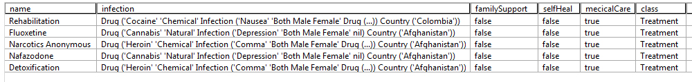

Fig. 10: Shows medical attention in medicalCare method column for the specific list of treatment name

1. Formula select: [:f | f herb]

Method : ^true ifTrue: [(molecular = 'C23H30N205' | molecular) = 'C21H30O2']



Fig. 11: Shows drug type herb or natural produce display in the column herb method

RDMS Class Diagram 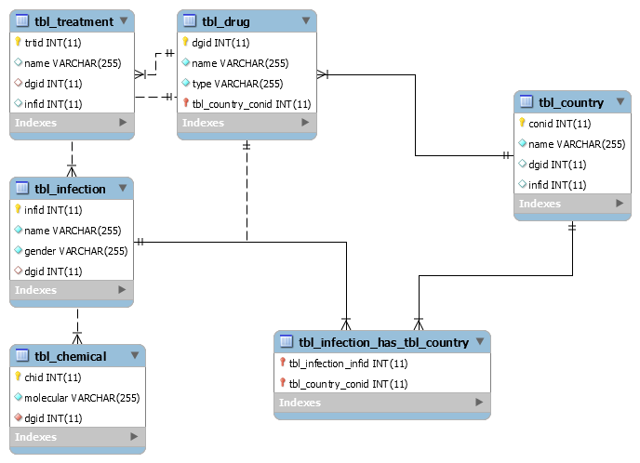

Fig. 12: Class Diagram of RDMS and its relationship

RDMS DATA

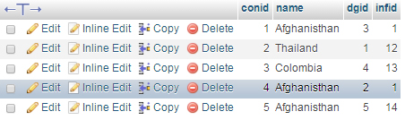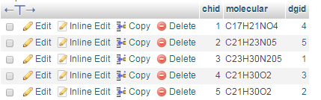All written information are in tabular format stored in database.

Fig. 14: tbl_country stored country name with two FK

Fig. 13: tbl_chemical stored molecular with drug FK id

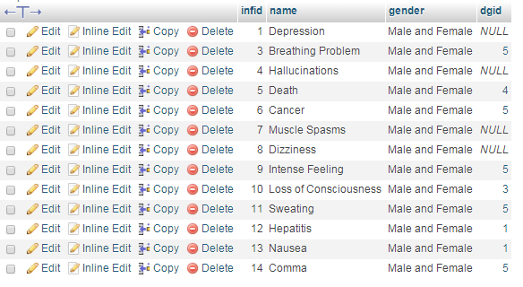

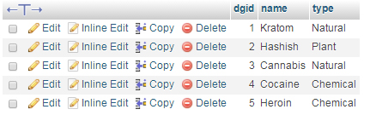

Fig. 15: tbl_drug stored drug name and type

Fig. 16: tbl_infection stored infection name and FK with drug table

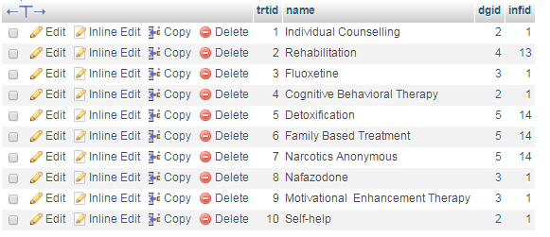

Fig. 17: tbl_treatment stored treatment name and two FK with drug table and infection table

RDMS Implementation

All written information like create, read, update, and delete and in short (CRUD) used as query in RDMS. The data fetch from select query and display in tabular format which can help to predict and to find the answer of infection and treatment also find the countries to produce and the combination of chemical molecules.

The queries are as follow below and its relatioship and effect to database:

1. SELECT COUNT('name') as drugTrafficklingCountry, name FROM tbl_country GROUP BY name;

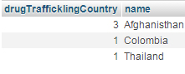

Fig. 18: Afghanisthan produce more than three drugs

1. SELECT tbl_infection.name AS infection, tbl_country.name AS country FROM tbl_infection INNER JOIN tbl_country ON tbl_country.infid = tbl_infection.infid WHERE tbl_country.name = "Afghanisthan";

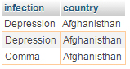

Fig. 19: Afghanisthan is various infected country by drugs

1. SELECT tbl_infection.name as infection, tbl_drug.name as drug FROM tbl_infection INNER JOIN tbl_drug ON tbl_infection.dgid = tbl_drug.dgid WHERE tbl_drug.dgid = 5;

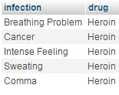

Fig. 20: Drug id 5 from drug table has various infections from the infection table, which combined each others

1. SELECT name as highInfected FROM tbl_infection WHERE name = 'Hallucinations' OR name='Loss of Consciousness' OR name='Cancer' OR name='Death' OR name='Comma';

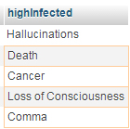

Fig. 21: This table shows the highly infected as per those listed infections from infection table

1. SELECT tbl_chemical.molecular as mostHarmChemical, tbl_drug.name as drug FROM tbl_chemical INNER JOIN tbl_drug ON tbl_chemical.dgid = tbl_drug.dgid WHERE tbl_drug.name = 'Cocaine' OR tbl_drug.name='Heroin';

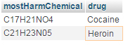

Fig. 22: This query shows the most harmful chemical of the related drug combined with two tables

1. SELECT tbl_chemical.molecular, tbl_drug.name as drug FROM tbl_chemical LEFT JOIN tbl_drug ON tbl_chemical.dgid = tbl_drug.dgid;

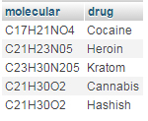

Fig. 23: Using left join to combine the related drug name with molecular of drug and chemical tables

1. SELECT tbl_treatment.name AS care, tbl_drug.name AS drug, tbl_infection.name AS infection FROM tbl_drug INNER JOIN tbl_infection ON tbl_drug.dgid = tbl_infection.dgid INNER JOIN tbl_treatment ON tbl_treatment.dgid = tbl_drug.dgid WHERE tbl_infection.name = 'Depression' OR tbl_infection.name = 'Comma' OR tbl_infection.name = 'Death' OR tbl_infection.name = 'Cancer' OR tbl_infection.name = 'Hallucinations'

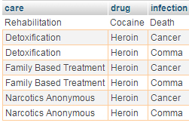

Fig. 24: Find out the care as per the infection from the drug, combining three tables

1. SELECT name,

( CASE WHEN name = 'Nafazodone' THEN 'Nafazodone' WHEN name = 'Fluoxetine' THEN "Fluoxetine" WHEN name = 'Rehabilitation' THEN "Rehabilitation" WHEN name = 'Detoxification' THEN "Detoxification" WHEN name = 'Narcotics Anonymous' THEN "Narcotics Anonymous" END ) AS medicalCare,

( CASE WHEN name = 'Motivational Enhancement Therapy' THEN 'Motivational Enhancement Therapy' WHEN name = 'Cognitive Behavioral Therapy' THEN "Cognitive Behavioral Therapy" WHEN name = 'Family Based Treatment' THEN "Family Based Treatment" WHEN name = 'Detoxification' THEN "Detoxification" END ) As familySupport,

( CASE WHEN name = 'Motivational Enhancement Therapy' THEN 'Motivational Enhancement Therapy' WHEN name = 'Self-help' THEN "Self-help" WHEN name = 'Individual Counselling' THEN "Individual Counselling" END ) As selfHeal FROM tbl_treatment;

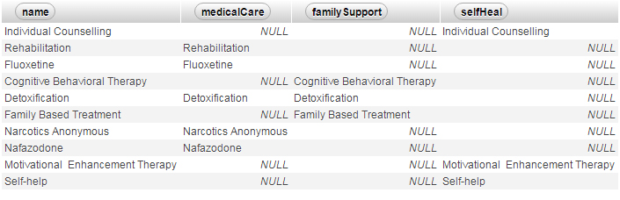

Fig. 25: Various kind of treatment like medicalCare, familySupport and selfHeal are categories as per the treatment list

Conclusion

From both Object Oriented Database System (OODS) and Relationship Database Management System (RDMS) all the information can fetch and display as per the effect on the system. In OODS all the data fetch as the instances of the object also there are the methods written where the function created to those methods whereas the RDMS the data are stored in tabular format and as per the primary and foreign key the data are fetched combining two or more than two tables. There is implemented of normalization in RDMS.

Whatever their system but both impact on the important data. They both shows the effect on human being lives by drug using and their infection, treatment, drug trafficking countries, the production, their chemical combined etc. By help of those information there may various future predictions, their solving problem and how may effect in future be able to easily assume.